Task -2 :- Build Your Student Digital Portfolio
Update or create profile in LinkedIn, Git Hub,Kaggle.
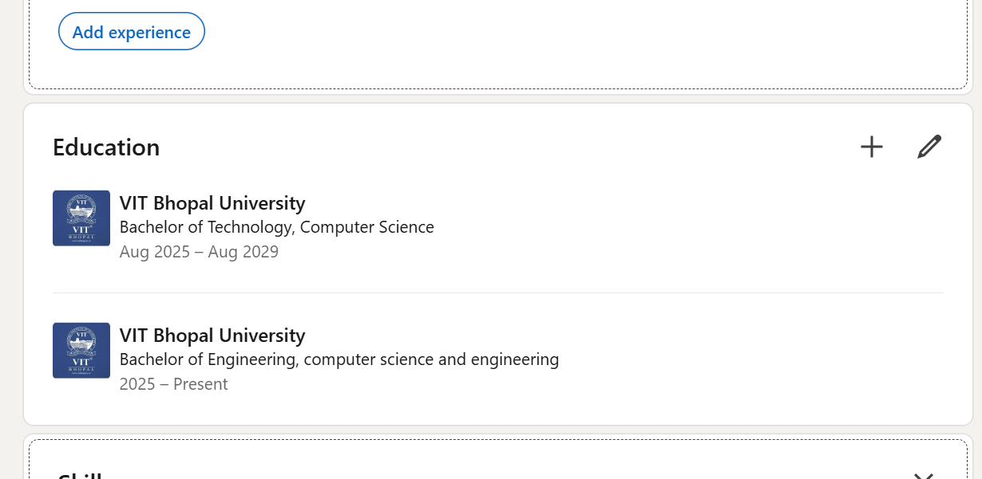
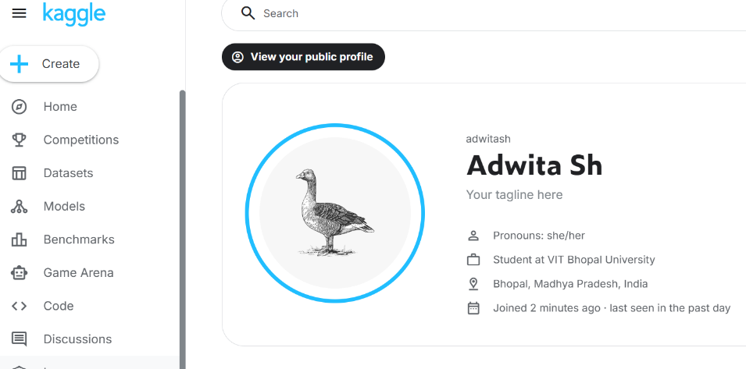

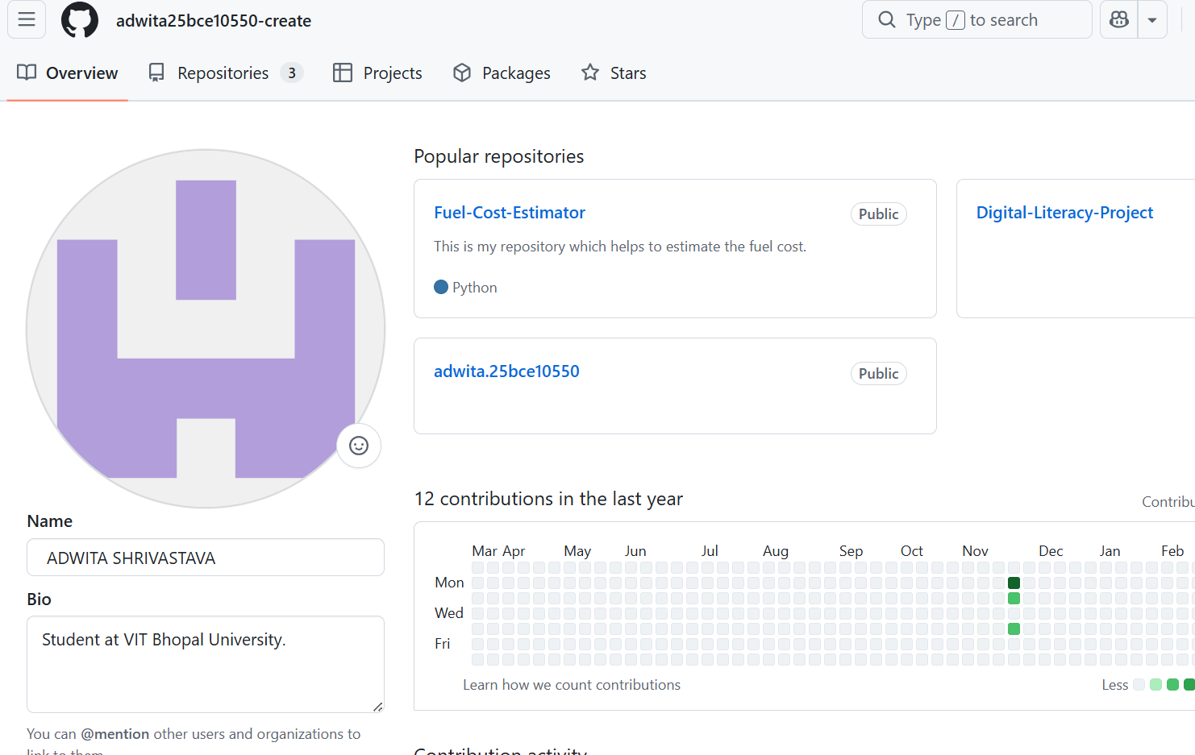

Report-
I have chose to use Kaggle , linkedln and Github as my tools. Kaggle is used for learning Machine learning .Github is platform that uses Git, an open source version control system for hosting and managing software development programs that helps in real time collaboration.Linkedln is a social media platform that helps people to communicate at professional level . It helps us to find opportunities that are available for us and connect with various organizations.
Using these tools in the next four years can help us take train ourselves and make us gain more opportunities easily. Github will help as brief about our projects easily . With the help of linkedln we can get more opportunities to connect with institutions for collaboration and internships. Kaggle is used to participate in predictive modeling competitions, explore/analyze datasets, host and share code via Jupyter Notebooks, and collaborate with other data scientists, acting as a crucial bridge between theoretical knowledge and practical application.

